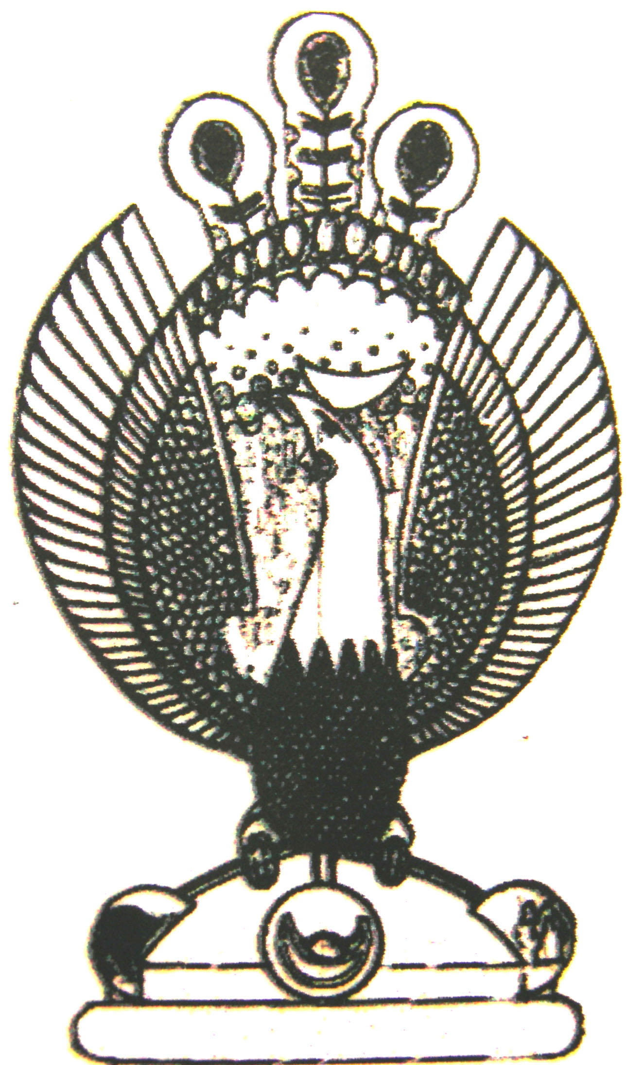

THE HERITAGE

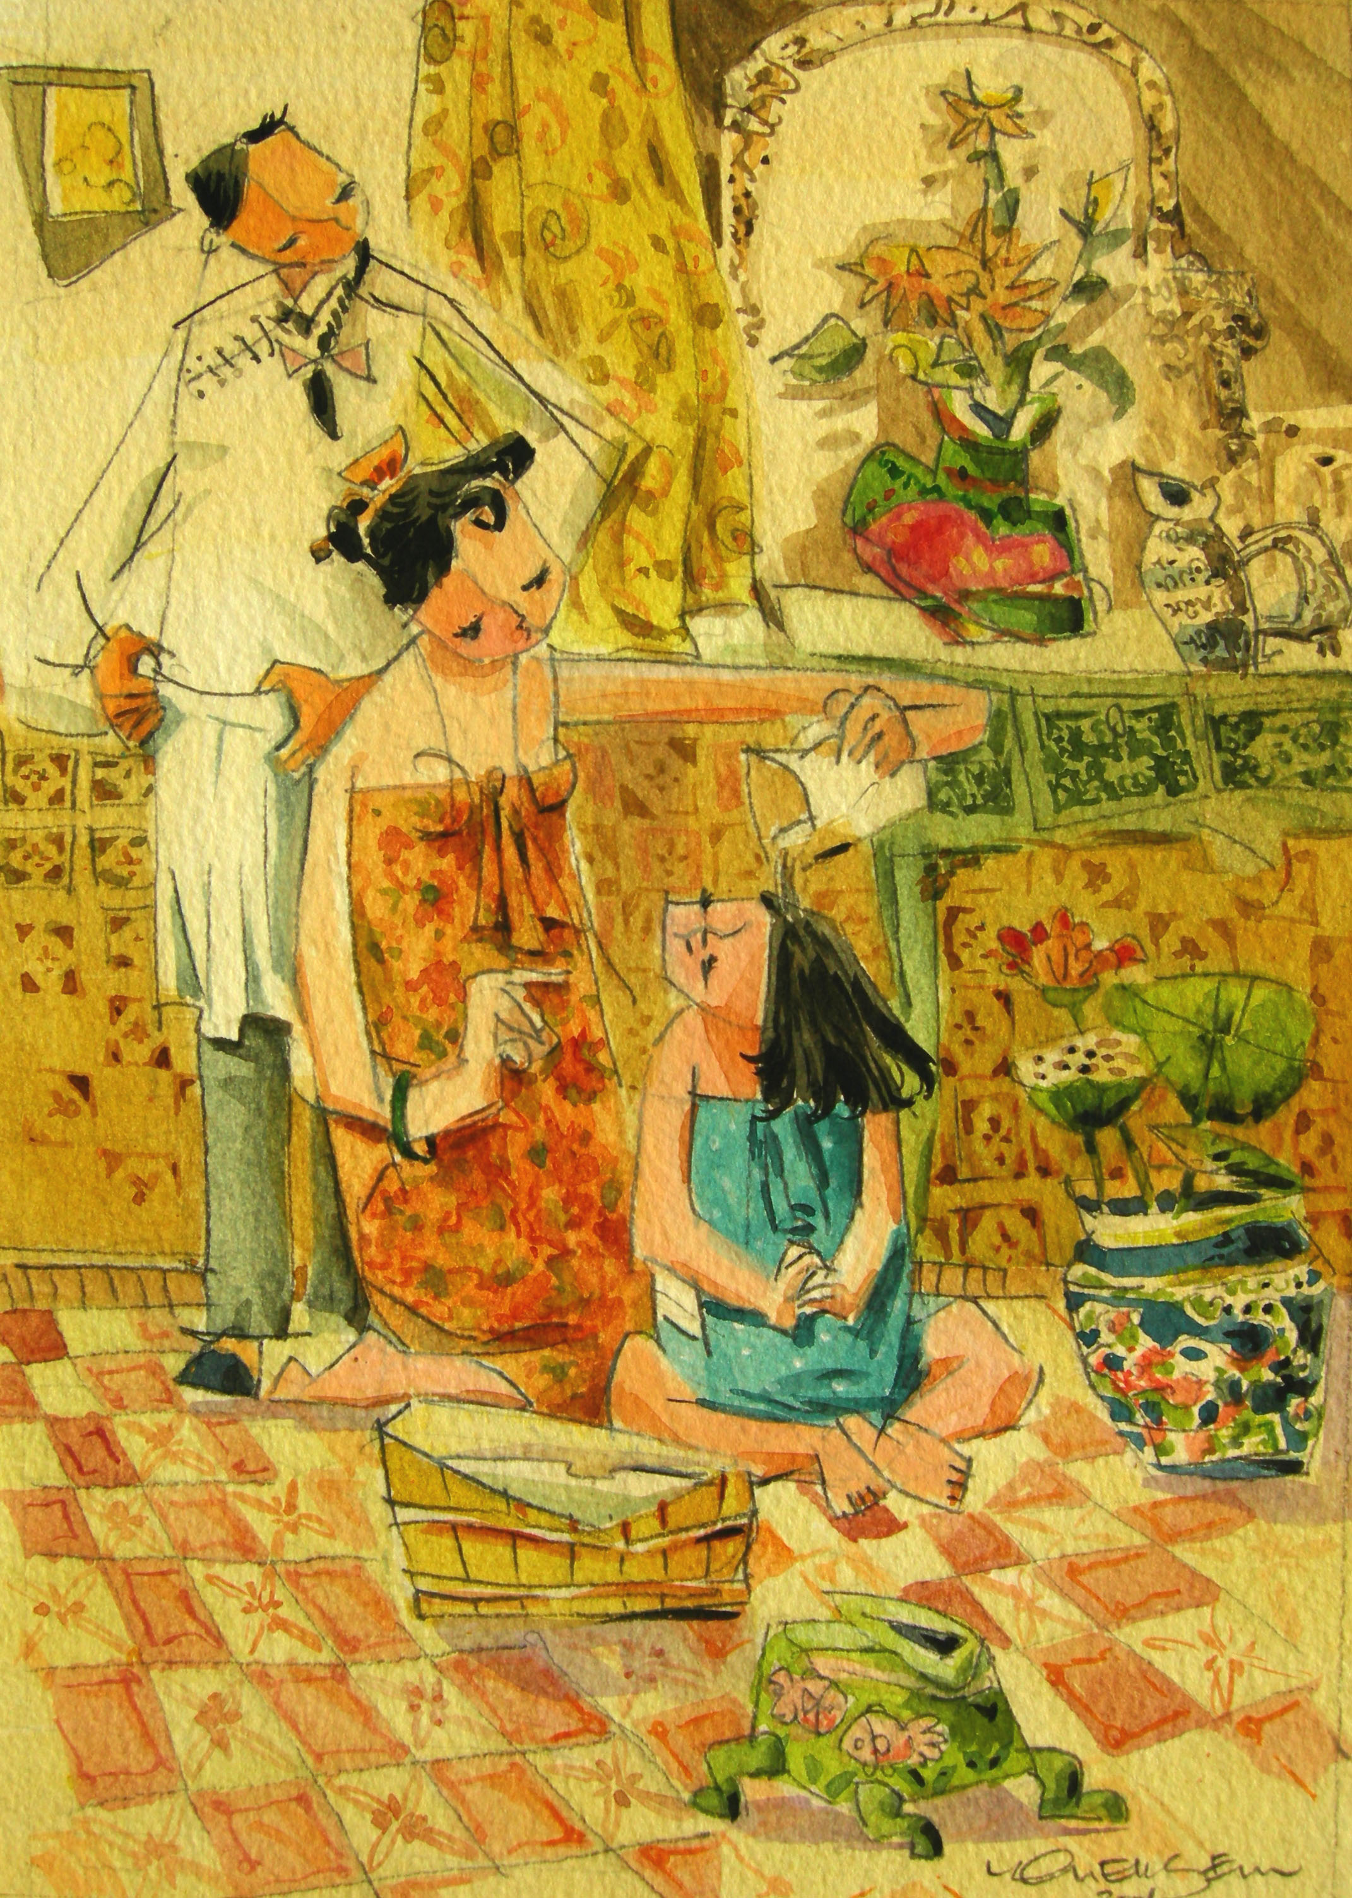
Mothercare
While a mother washes her daughter’s hair, she would teach her daughter about the ‘birds and the bees’

